From Standard to Block
Nate Heiss
Most of you are familiar with the Standard environment by now. You know what you like, and you play it often. Friday Night Magic is great fun and it keeps the Standard environment fresh. Who doesn't enjoy a night of Magic with friends? But maybe you are looking for more...
I get asked three questions more than any others.
The first is: How do I become a pro?
The second is: How should I fix my deck so I can become a pro?
The third is: What deck should I play?
This article can kill three birds with one stone.
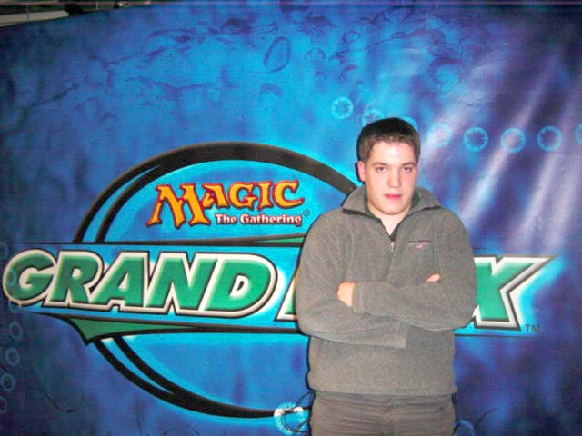
The ultimate pro: Kai Budde
First of all, anyone can be a pro. It takes more than just being a good player. Kai Budde is a good player (understatement maybe), but no one considered him a pro until he won his first Pro Tour. Three Pro Tours and four Grand Prix later, he is more like the pro incarnate.
The second question can be answered by looking at the below lists and trying to understand why the decks are built the way they are.
In answer to the third question, I have always believed that being comfortable playing with a deck is more important then if that particular deck is the best in the format. Because of that, I always tell people to play what they are comfortable with. However, when you are looking at a format that you have never played before, like IBC, it can be difficult to gauge what you would be comfortable playing. Below, you will find a list of the most popular Standard decks and a corresponding list of IBC decks that you might be comfortable playing given each Standard deck.
First up, we have Dark Fires. I won't list regular Fires, but the same applies:
Jan Tomcani
Dark Fires
Main Deck |  | Sideboard
8 Forest  3 Mountain  2 City of Brass  2 Llanowar Wastes  2 Sulfurous Springs  3 Karplusan Forest  4 Rishadan Port  4 Llanowar Elves  4 Birds of Paradise  4 Blastoderm  4 Thornscape Battlemage  2 Spiritmonger  2 Flametongue Kavu  2 Kavu Chameleon | 4 Fires of Yavimaya  4 Saproling Burst  4 Fire/Ice  2 Urza's Rage | 2 Kavu Chameleon  2 Obliterate  3 Thunderscape Battlemage  3 Blood Oath  3 Boil  2 Tangle
Fires and Dark Fires are both medium speed decks that utilize beasties that come out stong and hit hard. The nearest IBC equivalent to this would be r-g:
Jason Means
Red-Green
Main Deck |  | Sideboard
1 Keldon Necropolis  4 Shivan Oasis  10 Forest  9 Mountain  2 Flametongue Kavu  4 Skizzik  4 Raging Kavu  4 Blurred Mongoose  4 Kavu Titan  4 Thornscape Familiar  4 Thornscape Battlemage | 4 Ghitu Fire  4 Scorching Lava  2 Urza's Rage | 3 Dodecapod  3 Jade Leech  4 Thunderscape Battlemage  1 Urza's Rage  2 Flametongue Kavu  2 Obliterate
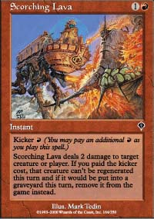
Both have a red-green base and have similar speed. It is important for the IBC version to play with Scorching Lava because of Spectral Lynx and Nightscape Familiar. This is a fine choice for the qualifiers. Fires players should feel comfortable attacking with Skizziks and kicking up Kavu Titans.
Now for Machine Head, from our world champion:

Tom Van De Logt
Machine Head
Main Deck |  | Sideboard
6 Swamp  6 Mountain  4 Rishadan Port  4 Urborg Volcano  4 Sulfurous Springs  4 Plague Spitter  3 Phyrexian Scuta  3 Skizzik  2 Flametongue Kavu  2 Crypt Angel  4 Blazing Specter | 4 Duress  4 Dark Ritual  4 Terminate  3 Vendetta  3 Urza's Rage | 4 Scoria Cat  3 Addle  2 Persecute  1 Pyroclasm  3 Phyrexian Arena  1 Flametongue Kavu  1 Crypt Angel
This deck makes great use of powerful creatures and burn spells. IBC has a very similar deck that also has a high quality distribution of spells.
Antoine Ruel
black-red
Main Deck |  | Sideboard
1 Keldon Necropolis  10 Mountain  10 Swamp  4 Urborg Volcano  4 Blazing Specter  2 Flametongue Kavu  3 Nightscape Familiar  4 Phyrexian Rager  3 Pyre Zombie  4 Shivan Zombie  4 Skizzik | 3 Addle  2 Ghitu Fire  4 Terminate  3 Void | 1 Addle  3 Crypt Angel  2 Flametongue Kavu  3 Phyrexian Arena  3 Ravenous Rats  3 Slay
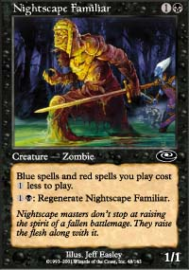
The most noticeable difference is the lack of Plague Spitter. If you want him (he is good versus green-red), you can pull the Nightscape Familiars for him. Watch out for Dodecapod!
Now we compare the popular Nether-Go deck with IBC:

Tommi Hovi
Nether-Go
Main Deck |  | Sideboard
1 Adarkar Wastes  1 Caves of Koilos  4 Coastal Tower  2 Dromar's Cavern  5 Island  4 Plains  3 Salt Marsh  4 Underground River  1 Dromar, the Banisher  3 Nether Spirit | 4 Probe  4 Fact or Fiction  4 Wrath of God  4 Counterspell  3 Dromar's Charm  3 Gerrard's Verdict  2 Dismantling Blow  2 Vindicate  2 Tsabo's Web  2 Memory Lapse  1 Disrupt  1 Absorb | 4 Samite Archer  4 Duress  3 Last Breath  2 Mageta the Lion  2 Seal of Cleansing
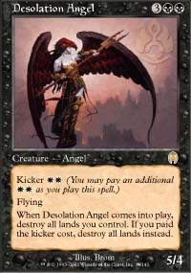
While the powerful Nether Spirit is not available, most of the spells are. No-Mar takes advantage of the same powerful u-b-w spells along with a versatile creature base made up of Spectral Lynx and Desolation Angel.

Sigurd Eskeland
No-Mar
Main Deck |  | Sideboard
4 Caves of Koilos  4 Coastal Tower  2 Dromar's Cavern  4 Island  4 Plains  4 Salt Marsh  4 Swamp  2 Desolation Angel  4 Spectral Lynx | 4 Dromar's Charm  4 Fact or Fiction  4 Gerrard's Verdict  4 Probe  3 Recoil  3 Rout  4 Vindicate  2 Yawgmoth's Agenda | 4 Gainsay  2 Lobotomy  3 Meddling Mage  2 Ravenous Rats  1 Rout  3 Slay
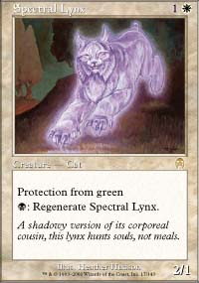
Those two decks are extremely similar. No-Mar may also satisfy the needs of the common u-w Millstone player. Even though No-Mar is a slow deck, the Spectral Lynxes can take it up a notch!
Now we take a look at Opposition-Orb. While there is no equivalent to Opposition in IBC, the tempo of this deck can be seen in certain other decks. Skies players should also enjoy this one...

Andrea Santin
Opposition-Orb
Main Deck |  | Sideboard
20 Island  2 Rishadan Port  3 Glacial Wall  4 Lord of Atlantis  4 Merfolk Looter  4 Rootwater Thief  3 Waterfront Bouncer | 3 Counterspell  3 Foil  3 Gush  4 Opposition  4 Static Orb  3 Thwart | 3 Chimeric Idol  1 Glacial Wall  3 Repulse  3 Stinging Barrier  1 Temporal Adept  3 Thieving Magpie  1 Thwart
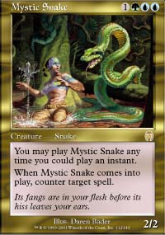
Any Opposition or Skies player knows that their game is all about tempo. They need to zig in the early game and zag in the late game. Opposition is Opposition-Orb's zag, while Skies uses free counters. G-u-r IBC Tempo uses bounce spells, burn and Mystic Snake to keep the dream alive.

David Kwan
Green-Blue-Red Tempo
Main Deck |  | Sideboard
4 Shivan Oasis  4 Shivan Reef  4 Yavimaya Coast  6 Forest  6 Island  4 Mystic Snake  4 Blurred Mongoose  4 Kavu Titan  4 Gaea's Skyfolk | 4 Prophetic Bolt  4 Fire/Ice  3 Repulse  4 Urza's Rage  3 Exclude  2 Fact or Fiction | 4 Gainsay  3 Tranquility  3 Jungle Barrier  3 Flametongue Kavu  1 Obliterate  1 Repulse
While this deck seems a bit unorthodox, it is actually quite powerful. Like Opposition-Orb or Skies, if it loses its Tempo, the game is most likely over. Luckily, in IBC, many of the decks have the same problem, so when two tempo decks run out of gas, there is still a chance to win the race.
Counter Rebels is somewhat representative of IBC as a whole because of the creature/counter tempo that is the cornerstone of the deck. Here is a likely Counter Rebel deck:
Elijah Pollock
Counter Rebels
Main Deck |  | Sideboard
9 Island  8 Plains  4 Coastal Tower  4 Adarkar Wastes  4 Ramosian Sergeant  3 Linn Sivvi, Defiant Hero  2 Defiant Vanguard  1 Ramosian Sky Marshal  1 Ramosian Lieutenant  2 Defiant Falcon  1 Rebel Informer  4 Meddling Mage | 3 Parallax Wave  4 Counterspell  3 Absorb  3 Disenchant  4 Brainstorm | 2 Mageta the Lion  3 Wrath of God  3 Gainsay  1 Disenchant  3 Disrupt  2 Teferi's Response  1 Thermal Glider
No IBC deck has the powerful Rebel engine, but the Solution makes use of cards like Repulse and Exclude to fuel the juices of Beatdown. Protection from red and green help a lot too.
Arthuri Bjork
New Solution
Main Deck |  | Sideboard
4 Caves of Koilos  4 Coastal Tower  2 Dromar's Cavern  5 Island  5 Plains  4 Salt Marsh  4 Galina's Knight  4 Meddling Mage  4 Spectral Lynx  4 Voice of All | 4 Absorb  4 Dromar's Charm  4 Fact or Fiction  4 Gerrard's Verdict  4 Vindicate | 2 Disrupt  1 Dodecapod  4 Emblazoned Golem  4 Gainsay  2 Slay  2 Unnatural Selection
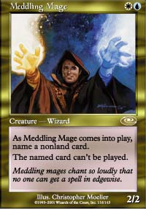
The Solution tries to be the ultimate metagamer. It tries to be Pro-everything and universally annoying. The good news is that this still works, even in a crazy format like IBC. It is a bit more Beatdown than Counter Rebels, but fans of the deck will instantly recognize the creature/counter motif.
Lastly we have good ol' blue-white. If we were playing rock/paper/scissors, this would be rock. Nothing beats rock... or at least that is how it's supposed to go. Control is one of the oldest staples of the game.

Brian Hegstad
Blue-White Control
Main Deck |  | Sideboard
4 Adarkar Wastes  4 Coastal Tower  9 Island  8 Plains | 4 Absorb  4 Accumulated Knowledge  4 Counterspell  4 Dismantling Blow  4 Fact or Fiction  2 Foil  3 Millstone  3 Story Circle  3 Tsabo's Web  4 Wrath of God | 2 Disenchant  3 Gainsay  2 Gerrard's Wisdom  3 Last Breath  4 Mageta, the Lion  1 Millstone
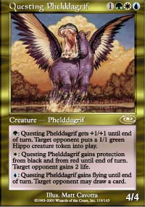
In IBC, the most control deck is Domain. If you like shutting down the creatures and casting powerful spells, this might be the deck for you. Like blue-white, it is very hard to play and there are many different ways to build it. Metagame is the big factor here.

Quentin Martin
Domain
Main Deck |  | Sideboard
2 Elfhame Palace  7 Forest  5 Island  1 Llanowar Wastes  1 Mountain  2 Plains  2 Swamp  2 Yavimaya Coast  1 Draco  1 Questing Phelddagrif  2 Sunscape Familiar | 3 Allied Strategies  4 Collective Restraint  1 Dromar's Charm  4 Evasive Action  3 Fact or Fiction  2 Global Ruin  4 Harrow  4 Lay of the Land  2 Legacy Weapon  1 Overgrown Estate  1 Pernicious Deed  1 Restock  1 Rout  1 Void  2 Worldly Counsel | 1 Benalish Emissary  1 Destructive Flow  3 Gainsay  3 Lobotomy  1 Overgrown Estate  1 Pernicious Deed  1 Powerstone Minefield  2 Questing Phelddagrif  1 Repulse  1 Vindicate
Now all of you Friday Night Magic players out there have a little better idea of what you might enjoy in the very interesting IBC format. Have fun with it while it lasts!

